St. John’s Episcopal Church
Kingsville, Maryland
Welcomes You
Our Vision Statement

We believe that together we will transform
the world with love: Come on in!

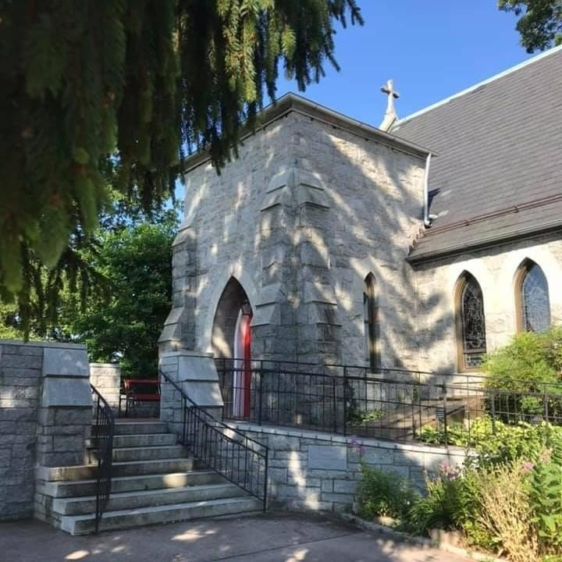

Fifth Sunday of Easter
May 7, 2023
10:30 am, Rite II

St. John’s Episcopal Church

11901 Belair Road, P. O. Box 187, Kingsville, MD 21087
FaceBook: St. John’s Episcopal, Kingsville, MD
Email: office@stjohnskingsville.org
Website: www.stjohnskingsville.org
Church Phone: 410-592-8570

Church Staff

Administrative Assistant: Angie Bosley
Organist/Choir Director: Nancy Heinold

The Vestry

Class of 2024 Class of 2025

Marguerite Lobb John Frost
Jacob Johnson Woodie Tingle

Officers
Ty Schwenk—Sr Warden Terry Roe—Jr. Warden
Elizabeth Healey—Treasurer Anne Leland-Registrar

Parish Committee Chairpersons

Altar Guild: Elizabeth Healey
Organ Restoration Committee: Nancy Heinold

10:30 am Worship
Holy Eucharist, Rite Two

Prelude:
The Word of God

Processional hymn: Jesus lives! thy terrors now Hymnal #194

Worship begins BCP 355

Gloria Hymnal #S-278
Glory to God in the highest,
and peace to his people on earth.
Lord God, heavenly King,
almighty God and Father,
we worship you, we give you thanks,
we praise you for your glory.
Lord Jesus Christ, only Son of the Father,
Lord God, Lamb of God,
you take away the sin of the world:
have mercy on us;
you are seated at the right hand of the Father:
receive our prayer.
For you alone are the Holy One,
you alone are the Lord,
you alone are the Most High,
Jesus Christ,
with the Holy Spirit,
in the glory of God the Father. Amen.

Celebrant: The Lord be with you.
People: And also with you.
Celebrant: Let us pray.

The Collect of the Day Kneel or stand as able BCP 215
Almighty God, whom truly to know is everlasting life: Grant us so perfectly to know your Son Jesus Christ to be the way, the truth, and the life, that we may steadfastly follow his steps in the way that leads to eternal life; through Jesus Christ your Son our Lord, who lives and reigns with you, in the unity of the Holy Spirit, one God, for ever and ever. Amen.
The congregation is seated.

A Reading from the Acts of the Apostles 7:55-60
Filled with the Holy Spirit, Stephen gazed into heaven and saw the glory of God and Jesus standing at the right hand of God. “Look,” he said, “I see the heavens opened and the Son of Man standing at the right hand of God!” But they covered their ears, and with a loud shout all rushed together against him. Then they dragged him out of the city and began to stone him; and the witnesses laid their coats at the feet of a young man named Saul. While they were stoning Stephen, he prayed, “Lord Jesus, receive my spirit.” Then he knelt down and cried out in a loud voice, “Lord, do not hold this sin against them.” When he had said this, he died.

Reader: The Word of the Lord.
People: Thanks be to God.

Psalm 31:1-5, 15-16 (Prayed as directed.)
1 In you, O Lord, have I taken refuge;
let me never be put to shame; *
deliver me in your righteousness.
2 Incline your ear to me; *
make haste to deliver me.
3 Be my strong rock, a castle to keep me safe,
for you are my crag and my stronghold; *
for the sake of your Name, lead me and guide me.
4 Take me out of the net that they have secretly set for me, *
for you are my tower of strength.
5 Into your hands I commend my spirit, *
for you have redeemed me,
O Lord, O God of truth.
15 My times are in your hand; *
rescue me from the hand of my enemies,
and from those who persecute me.
16 Make your face to shine upon your servant, *
and in your loving-kindness save me.

A Reading from the First Letter of Peter 2:2-10
Like newborn infants, long for the pure, spiritual milk, so that by it you may grow into salvation— if indeed you have tasted that the Lord is good. Come to him, a living stone, though rejected by mortals yet chosen and precious in God’s sight, and like living stones, let yourselves be built into a spiritual house, to be a holy priesthood, to offer spiritual sacrifices acceptable to God through Jesus Christ. For it stands in scripture: “See, I am laying in Zion a stone, a cornerstone chosen and precious; and whoever believes in him will not be put to shame.”
To you then who believe, he is precious; but for those who do not believe, “The stone that the builders rejected has become the very head of the corner”, And “A stone that makes them stumble, and a rock that makes them fall.” They stumble because they disobey the word, as they were destined to do. But you are a chosen race, a royal priesthood, a holy nation, God’s own people, in order that you may proclaim the mighty acts of him who called you out of darkness into his marvelous light. Once you were not a people, but now you are God’s people; once you had not received mercy, but now you have received mercy.

Reader: The Word of the Lord.
People: Thanks be to God.

Gradual hymn: O Love of God, how strong and true Hymnal #455

The Gospel
Priest: The Holy Gospel of our Lord Jesus Christ according to John 14:1-14

People: Glory to you, Lord Christ.
Jesus said, “Do not let your hearts be troubled. Believe in God, believe also in me. In my Father’s house there are many dwelling places. If it were not so, would I have told you that I go to prepare a place for you? And if I go and prepare a place for you, I will come again and will take you to myself, so that where I am, there you may be also. And you know the way to the place where I am going.” Thomas said to him, “Lord, we do not know where you are going. How can we know the way?” Jesus said to him, “I am the way, and the truth, and the life. No one comes to the Father except through me. If you know me, you will know my Father also. From now on you do know him and have seen him.”
Philip said to him, “Lord, show us the Father, and we will be satisfied.” Jesus said to him, “Have I been with you all this time, Philip, and you still do not know me? Whoever has seen me has seen the Father. How can you say, ‘Show us the Father’? Do you not believe that I am in the Father and the Father is in me? The words that I say to you I do not speak on my own; but the Father who dwells in me does his works. Believe me that I am in the Father and the Father is in me; but if you do not, then believe me because of the works themselves. Very truly, I tell you, the one who believes in me will also do the works that I do and, in fact, will do greater works than these, because I am going to the Father. I will do whatever you ask in my name, so that the Father may be glorified in the Son. If in my name you ask me for anything, I will do it.”

Priest: The Gospel of the Lord.
People: Praise to you, Lord Christ.
Sermon Rev. Canon Stuart Wright+

Nicene Creed Please stand as able BCP 358
We believe in one God,
the Father, the Almighty,
maker of heaven and earth,
of all that is, seen and unseen.
We believe in one Lord, Jesus Christ,
the only Son of God,
eternally begotten of the Father,
God from God, Light from Light,
true God from true God,
begotten, not made,
of one Being with the Father.
Through him all things were made.
For us and for our salvation
he came down from heaven:
by the power of the Holy Spirit
he became incarnate from the Virgin Mary,
and was made man.
For our sake he was crucified under Pontius Pilate;
he suffered death and was buried.
On the third day he rose again
in accordance with the Scriptures;
he ascended into heaven
and is seated at the right hand of the Father.
He will come again in glory to judge the living and the dead,
and his kingdom will have no end.
We believe in the Holy Spirit, the Lord, the giver of life,
who proceeds from the Father and the Son.
With the Father and the Son he is worshiped and glorified.
He has spoken through the Prophets.
We believe in one holy catholic and apostolic Church.
We acknowledge one baptism for the forgiveness of sins.
We look for the resurrection of the dead,
and the life of the world to come. Amen.

Prayers of the People Form III BCP 387

Confession of Sin BCP 359

The Peace BCP 360

Welcome & Announcements The congregation is seated.

Offertory anthem: Come All Ye Thirsty (Choir)
Karen Smith-Manar, Bassoon

Presentation Hymn Please stand as able
Praise God, from whom all blessings flow; praise him, all creatures here below; praise him above, ye heavenly host: praise Father, Son, and Holy Ghost.

The Holy Communion

THE GREAT THANKSGIVING: Eucharistic Prayer B BCP 367

Sanctus Hymnal #S-128
Holy, Holy, Holy Lord, God of power and might,
heaven and earth are full of your glory.
Hosanna in the highest.
Blessed is he who comes in the name of the Lord.
Hosanna in the highest.

The Lord’s Prayer BCP 364

Invitation to Communion

The Breaking of the Bread

Communion hymn: Come with us, O blessed Jesus Hymnal #336

The Post Communion Prayer BCP 365

Blessing

Recessional hymn: Christ is made the sure foundation Hymnal #518

The Dismissal

Please join us in fellowship as we celebrate Rev. Elizabeth at her Farewell Luncheon at Noon today.

Serving Today

Celebrant & Preacher: Rev. Canon Stuart Wright+
Old Testament: Barb Daniel
Psalm: Jacob Johnson
New Testament: Ty Schwenk
Prayers of the People: Ty Schwenk
Server: Marguerite Lobb
Music Director: Nancy Heinold
Altar Guild: Stephanie Duchacek and Sandy Roe
Choir: Anne Leland, Nancy Dellinger, Liz Healey, Camy Schwenk,
Karen Smith-Manar, Jacob Johnson, Ty Schwenk

Altar Flowers
Given to the Glory of God

By The Healey Family
in memory of Lorraine Healey on the occasion
of her 100th Birthday
St. John’s Parish Prayer List

Additions and corrections may be made to our Parish Prayer List at any time. All names will be automatically removed from the Parish Prayer List on the 1st Sunday of each month unless you request otherwise. Please contact Angie at <office@stjohnskingsville.org> or 410-592-8570 in the church office with all changes by 10 am Thursdays. Thank you.

We Pray for Those in Need:

Ivan, Lisa, Peter, Sarah Sutherland, Melissa Heaver, Liz Rawl, Ricky Carter, Marilyn Stephenson, Charlotte Williams (small child), Cleo Collins, Sid & Joan Pyle, Karen Sugden, DeMarino Family, Jenny, Lisa, Jennifer, Dylan, Gary, Barbara Goldsmith, Thelma, Paul Edwards, James Kneussl, Kim Collins-Appel, Ronnee Congleton (pancreatic cancer), Stephanie Payton, Jim & Chris Carden and family, Terry Barrett, Rev. Tony and Deacon Linda Hollis, Anne Leland, Peggie Dietz, Barnabas & Sarah, Stacey Bell, Thomas Proctor.

We Pray for our Homebound

Lily John, Barbara Miller, Nancy Barnhart, Robin Dilworth

We pray for the Church and the World:

For Most Rev’d. Justin Welby, Archbishop of Canterbury; for The Most Rev’d. Michael Curry, our Presiding Bishop; for Right Rev’d. Eugene Sutton, our Bishop; for the Rt. Rev’d Robert Ihloff, our Assisting Bishop, for our Bishop Co-Adjutor Elect, Carrie Schofield Broadbent, for our Rector, Rev. Elizabeth Sipos, for the Wardens, Vestry, Staff, and all members and friends of St. John’s Church.

For the leaders of all nations, especially for Joseph, our President; for Wes, our Governor; for Brandon, Nick, John and Bob, who lead our City and Counties. We pray for all children and youth; for the homeless, the unemployed, and the hungry. We pray for the safety of our loved ones and friends serving in the Armed Forces at home and abroad, and for our enemies, that all our hearts may be turned toward peace throughout the world.

From the Treasurer
May ’23 Income vs. Expenses:

Projected May Expenses: $12,990
Monies Received as of 5/4: $ 6,090

Amount Needed to Meet Expenses: $6,900

April ’23 Income vs. Expenses Recap:

Projected April Expenses: $13,990
Monies Received as of 4/30: $13,702

Thank You!

A few dates to put in your calendar:
May 7th - Rev. Elizabeth’s Farewell Luncheon, in place of Potluck Sunday
May 13th - Church Clean Up Day, 9am-12pm
May 20th - Flea Market
May 21st - Auxiliary Meeting after the 10:30 service
June 2nd - Bingo
July 4th - July 4th Parade
September 16th - Flea Market
November 18th - Christmas Bazaar
We are also going to have St. John’s shirts available for a nominal charge.
As you can see, so much going on and everyone’s help is needed to make it a success. If you can any time/talent it is always appreciated.

The Potluck will be the first Sunday of the month with Coffee Hour on all other Sundays.


FLEA MARKET!
On Saturday May 20, from 8:00am – 1:00pm St. John’s will be hosting a community flea market. If you have any gently used items (no clothes), feel free to drop them off, during office hours, for the Church’s table. If you know anyone who might be interested in participating, invite them to contact the church for details. The office number is 410-592-8570 or email at office@stjohnskingsville.org

CALLING ALL BAKERS!
If you can, please bake cookies or brownies to sell at the flea market. Please package 4 cookies to a bag and 2 brownies to a bag. They can be dropped off on Friday, 5/19, 11-3 or 5-7.

Please consider signing up to help with the flea market event. Just give us a call and let us know if you’re available. Michele, 443-463-6333 or office, 410-592-8570. Sign-up sheet is also in the back of the church.

Barb Daniel would like help on Thursday or Friday, 5/18 or 5/19 for pricing flea market items for the church table. You can call Barb at 410-877-2962.

Please let us know if you need a flyer for the event and we’ll send you one.

